**Case Study 3 : Analyzing Retail Sales Data with Azure Synapse Analytics**

**Client:** XYZ Retail Inc.

**Objective:** To leverage Azure Synapse Analytics for data integration, transformation, and analysis to gain insights from retail sales data.

**Background:** XYZ Retail Inc. needs to analyze retail sales data stored in Azure Blob Storage using Azure Synapse Analytics. The goal is to perform data transformation and analysis to generate actionable insights, such as total sales per store and sales trends over time.

**Requirements:**

1. **Data Storage:**
   * **Source Container:** source-data in Azure Blob Storage for raw CSV files.
2. **Data Processing and Analysis:**
   * **Data Ingestion:** Load data from Azure Blob Storage into Azure Synapse Analytics.
   * **Data Transformation:** Perform basic transformations such as cleaning and aggregating data.
   * **Data Analysis:** Execute SQL queries to analyze the data and generate insights.

**High-Level Steps:**

**1. Set Up Azure Blob Storage**

1. **Create Storage Account:**
   * **Storage Account Name:** xyzretailstorage
   * **Resource Group:** RetailDataGroup
   * **Region:** Choose an appropriate region (e.g., East US)
2. **Create a Container:**
   * **Container Name:** source-data
3. **Upload Sample Data:**
   * Upload sales_data.csv to the source-data container.

**2. Set Up Azure Synapse Analytics**

1. **Create an Azure Synapse Workspace:**
   * **Workspace Name:** RetailSynapse
   * **Resource Group:** RetailDataGroup
   * **Region:** Same as storage account (e.g., East US)
2. **Create a Dedicated SQL Pool:**
   * **SQL Pool Name:** RetailSQLPool
   * Configure a dedicated SQL pool with appropriate performance levels.

**3. Ingest Data into Azure Synapse Analytics**

1. **Create Linked Service for Azure Blob Storage:**
   * Go to your Synapse workspace.
   * Navigate to **Manage** > **Linked services**.
   * Click **+ New** and select **Azure Blob Storage**.
   * Configure the connection to the xyzretailstorage account using the storage account connection string.
2. **Create External Data Source:**
   * In Synapse Studio, open **Develop** and create a new SQL script.
   * Create an external data source to access data from Azure Blob Storage.
3. **Create External File Format:**
   * Define the file format for reading CSV files.
4. **Create External Table:**
   * Define the schema for the external table to query the CSV data.

**4. Transform and Analyze Data**

1. **Create SQL Scripts for Transformation:**
   * Write SQL queries to transform the data, such as aggregating sales by date and store.

Case study3:

Azure synapse:

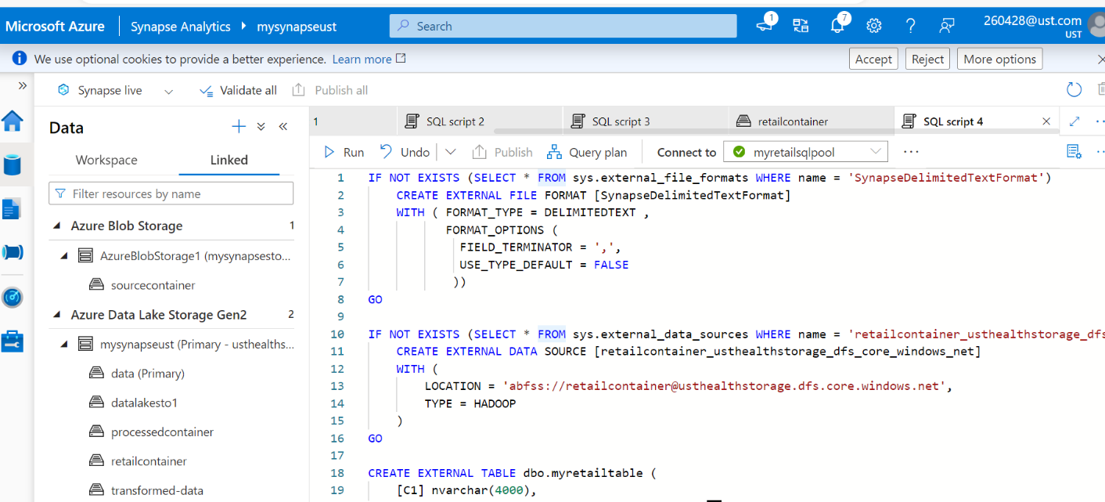

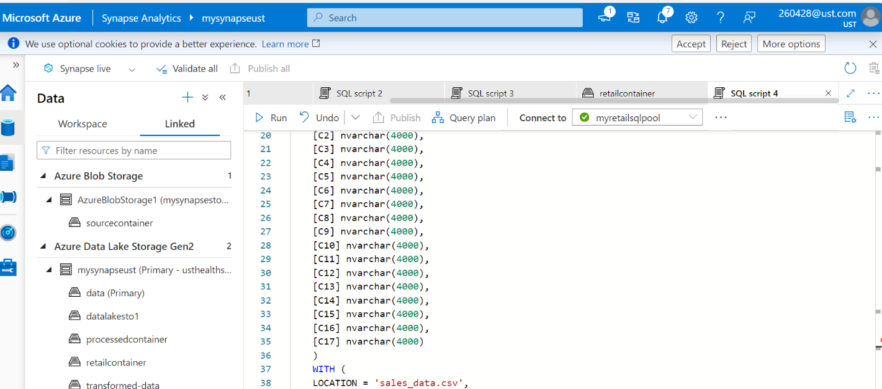

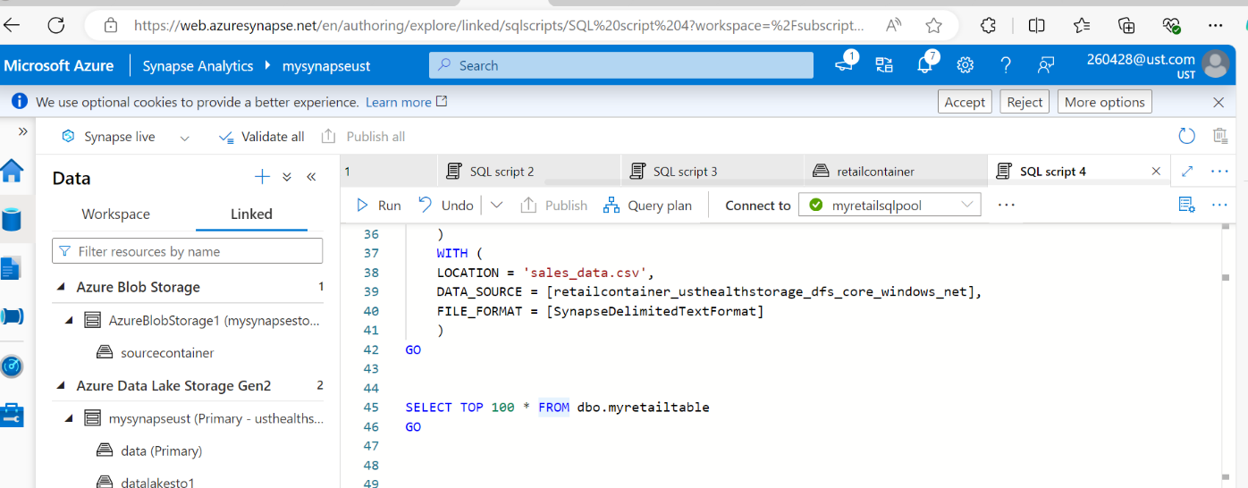

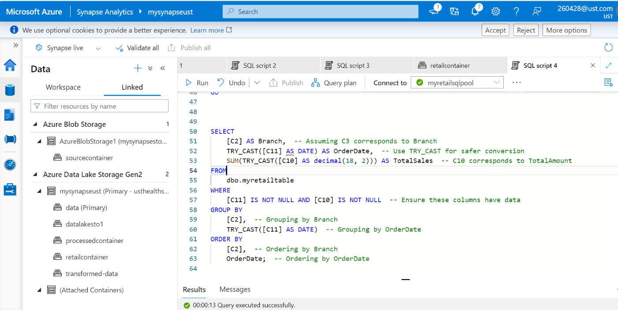

o/p:

